Welcome to 7M Social Studies

With a focus on World History, student will explore the following topics:
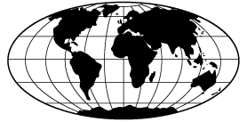
- World Geography
- Global Quality of Life
- Ways of Life in Africa, Asia
or Australasia
- Human Impact in Europe or
the Americas

___________________________________________________________________

Social Studies consists of the following learning categories.
Report card weightings are shown in parenthesis.

Knowledge and Understanding (50%): Students will understand and apply key concepts related to citizenship, history, geography, identity, culture, community, global interdependence, power and authority, economics and resources.

Research and Communication (30%): Students will pose questions related to topics and themes, collect and interpret information, record and organize information and ideas, express and share information and ideas through a variety of media.

Critical Thinking and Citizenship (20%): Students will think critically and creatively about topics and themes, propose alternate approaches to social issues, take an informed and ethically defendable stance on social issues, and accept diversity and recognize human commonalities in a changing and complex world.

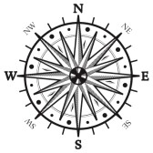
The above learning categories will be explored and demonstrated by a variety of methods including group/partner activities, classroom discussions, debates, current event projects, creative writing pieces, visual arts etc.

Assessment of the above outcomes will be reported using the following scale:

4 (80% - 100%) - Thorough understanding and in-depth application of concepts and skills
3 (70% - 79%) - Very good understanding and application of concepts and skills
2 (60% - 69%) - Basic understanding and some application of concepts and skills
1 (50% - 59%) - Limited understanding and minimal application of concepts and skills
ND (less than 50%) - Does Not yet Demonstrate the required understanding and application
of concepts and skills

